- On balance, we expect the Monetary Policy Committee will cut Bank Rate by 25bps at next week's meeting. But it's a very close call and will likely be another split decision, with Governor Andrew Bailey casting the decisive vote. If the Bank of England doesn't cut in December, we think it will cut in February instead.
- Bailey's statement in the November minutes suggested evidence that inflation is falling would be enough to justify switching his vote. November inflation data – due to be published on Wednesday – could be pivotal. Though we think the figure will be higher than that forecast by BoE staff, it should be lower than September's outturn, fulfilling Bailey's criteria for cutting.
Since the summer, the Bank of England's Monetary Policy Committee has split into two camps. Four members are concerned that structural shifts in inflation expectations and price setting make it more likely inflation will remain high. Four others are worried about downside risks to inflation from weaker activity. Governor Andrew Bailey has been the swing voter at two of the past three meetings, tipping the balance for a cut in August and a hold in November. Bailey's vote will likely prove decisive again in December.
In November, for the first time the minutes contained a paragraph from each member summarising their views (Table 1 shows the key quotes for each member). These contributions suggested the views of the two rival camps were well entrenched and testimony from four members at the Treasury Select Committee on December 9 reinforced that view.
Bailey's paragraph suggested that his vote in November was finely balanced. He felt that "upside risks to inflation have become less pressing" and that "the latest CPI data were promising", but suggested he wanted to see more evidence that inflation was falling before voting to cut. Inflation fell to 3.6% in October from 3.8% in September. November data will be published on December 17, the day before the MPC announcement. We expect the headline rate to hold steady at 3.6% (Chart 1), which is 0.2ppts above the BoE's staff forecast. But it could be interpreted as fulfilling Bailey's criteria because inflation would still be lower than it was ahead of the November meeting.
Chart 1: Inflation should be lower than it was before the November meeting
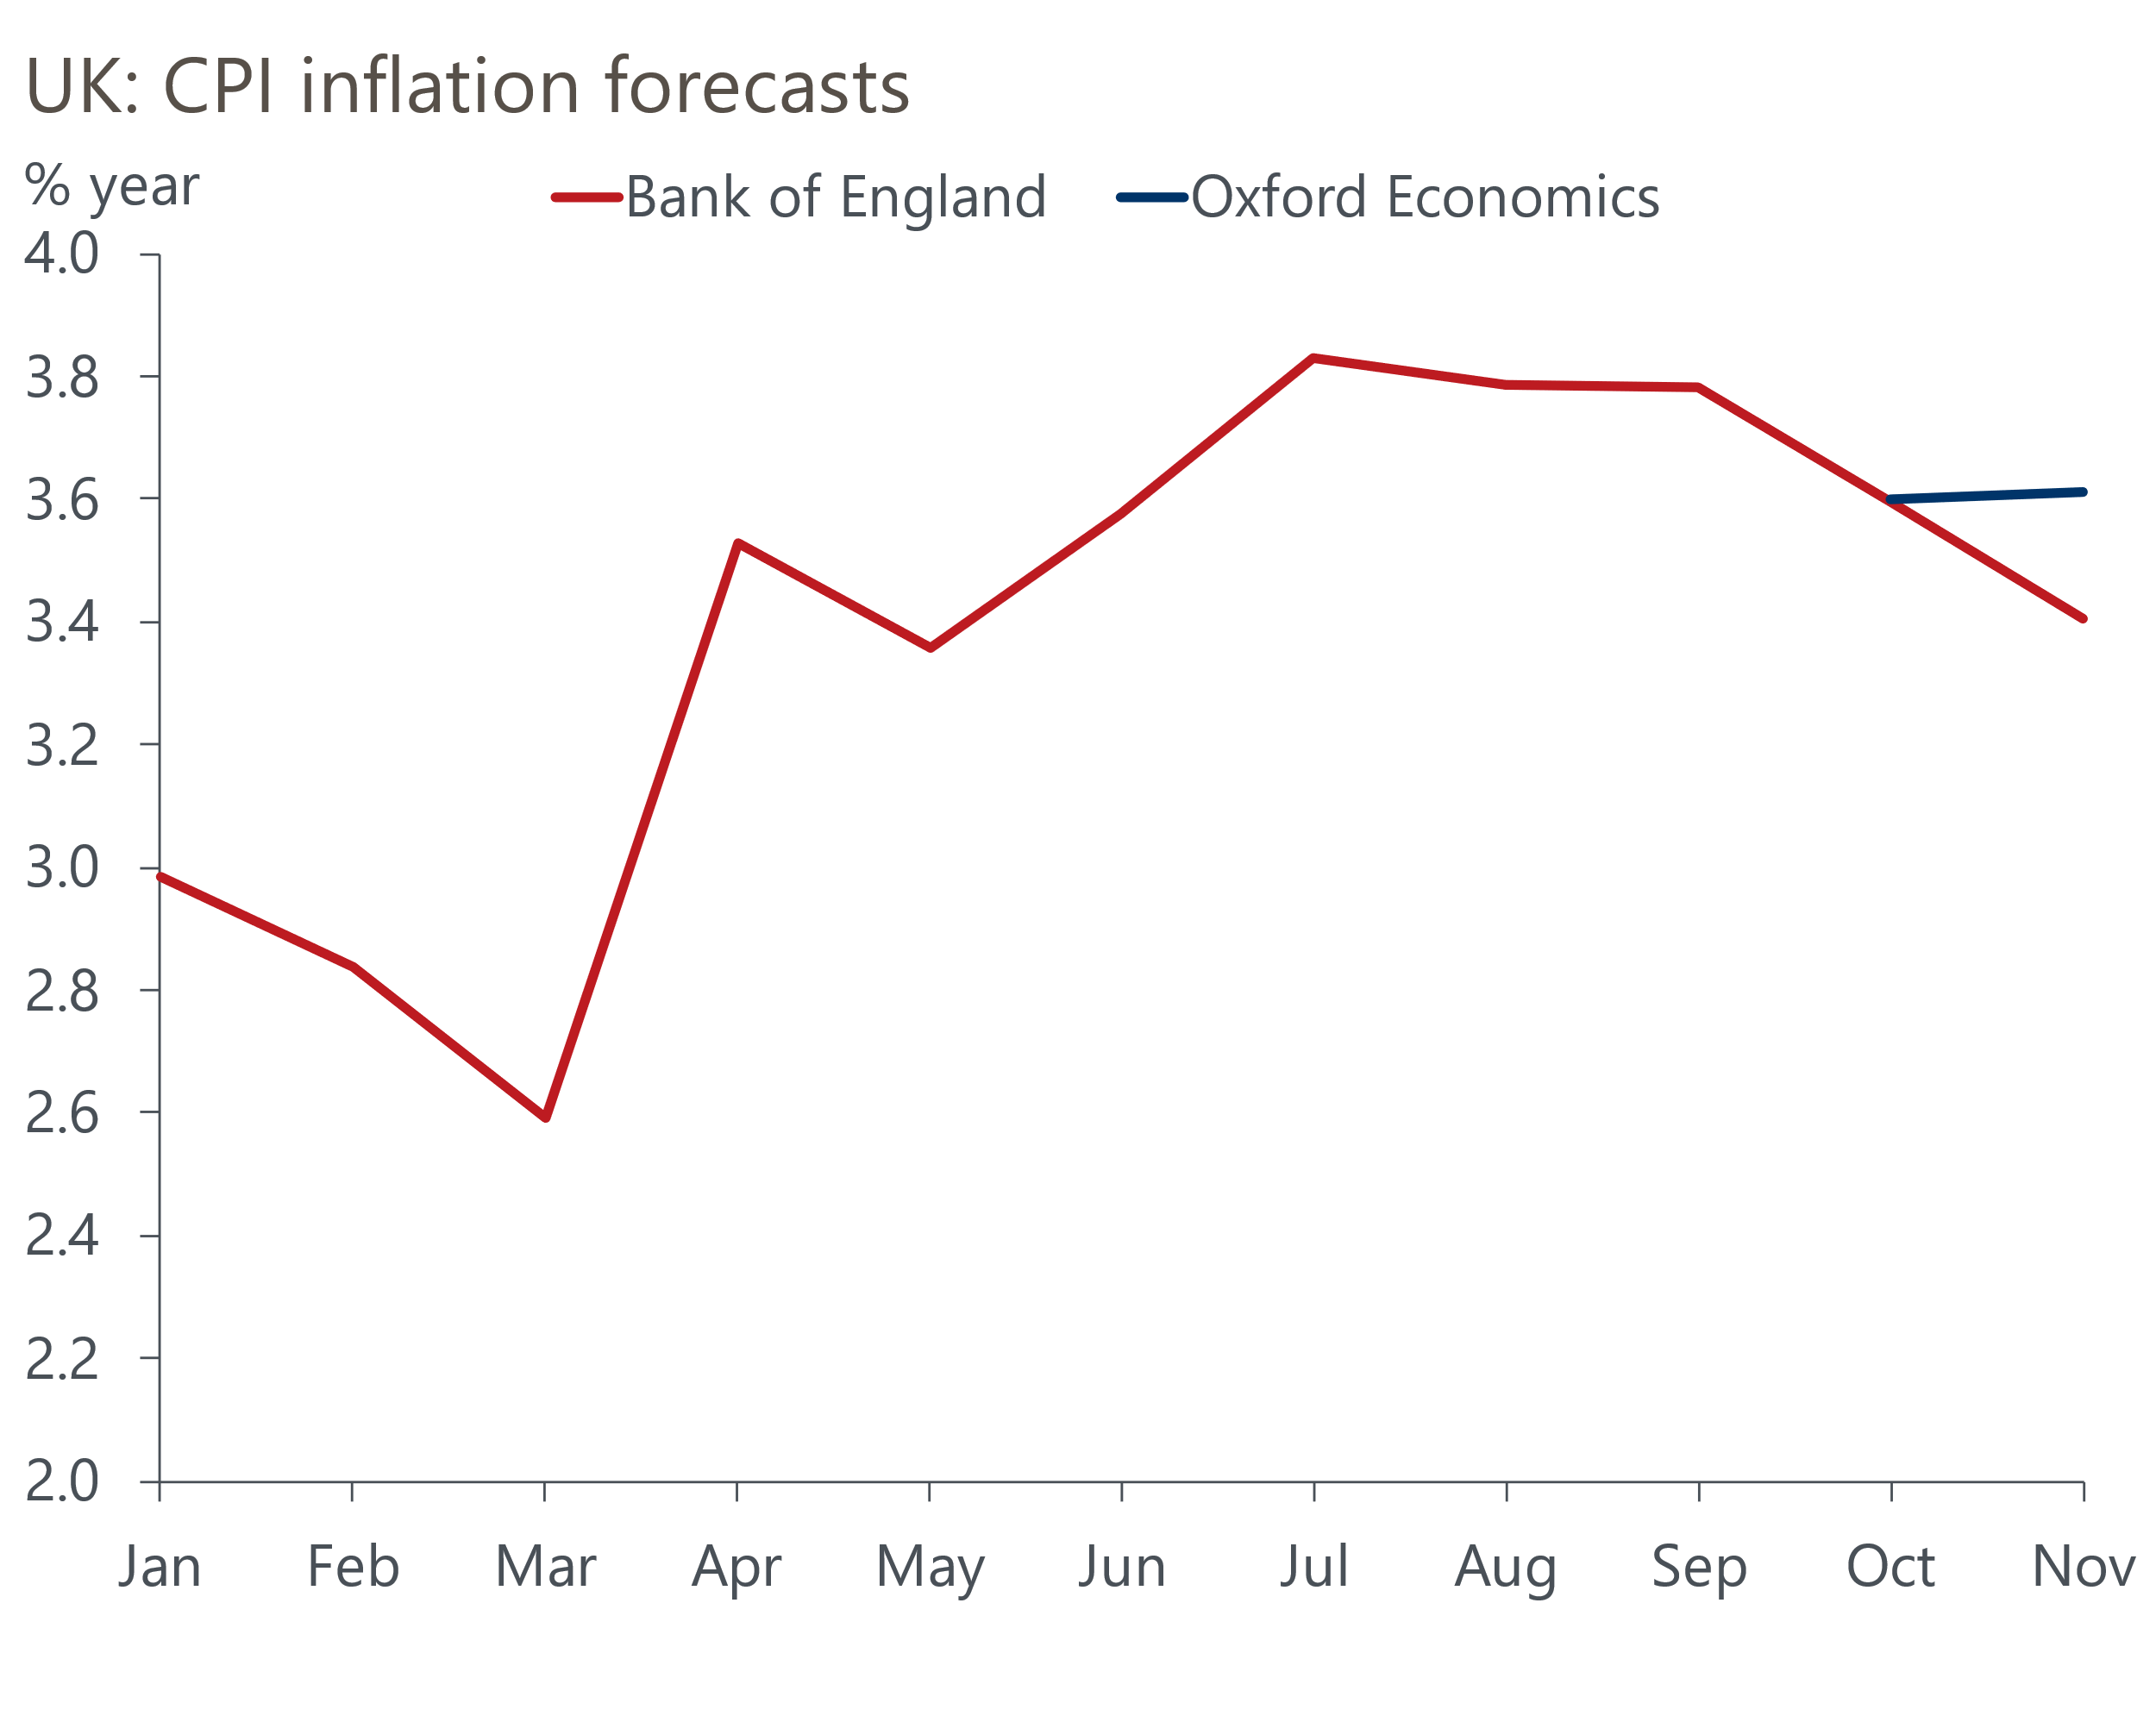
Sources: Oxford Economics, Bank of England

Bailey also suggested that market pricing at the time of the November meeting was "a fair description of my position." When Bailey wrote that line, markets put a 60%-70% chance on a December cut and fully priced a cut by February. Since then, pricing has firmed, implying a probability of nearly 90% that Bank Rate will be cut next week (Chart 2).
Chart 2: Market pricing implies a December rate cut is almost certain
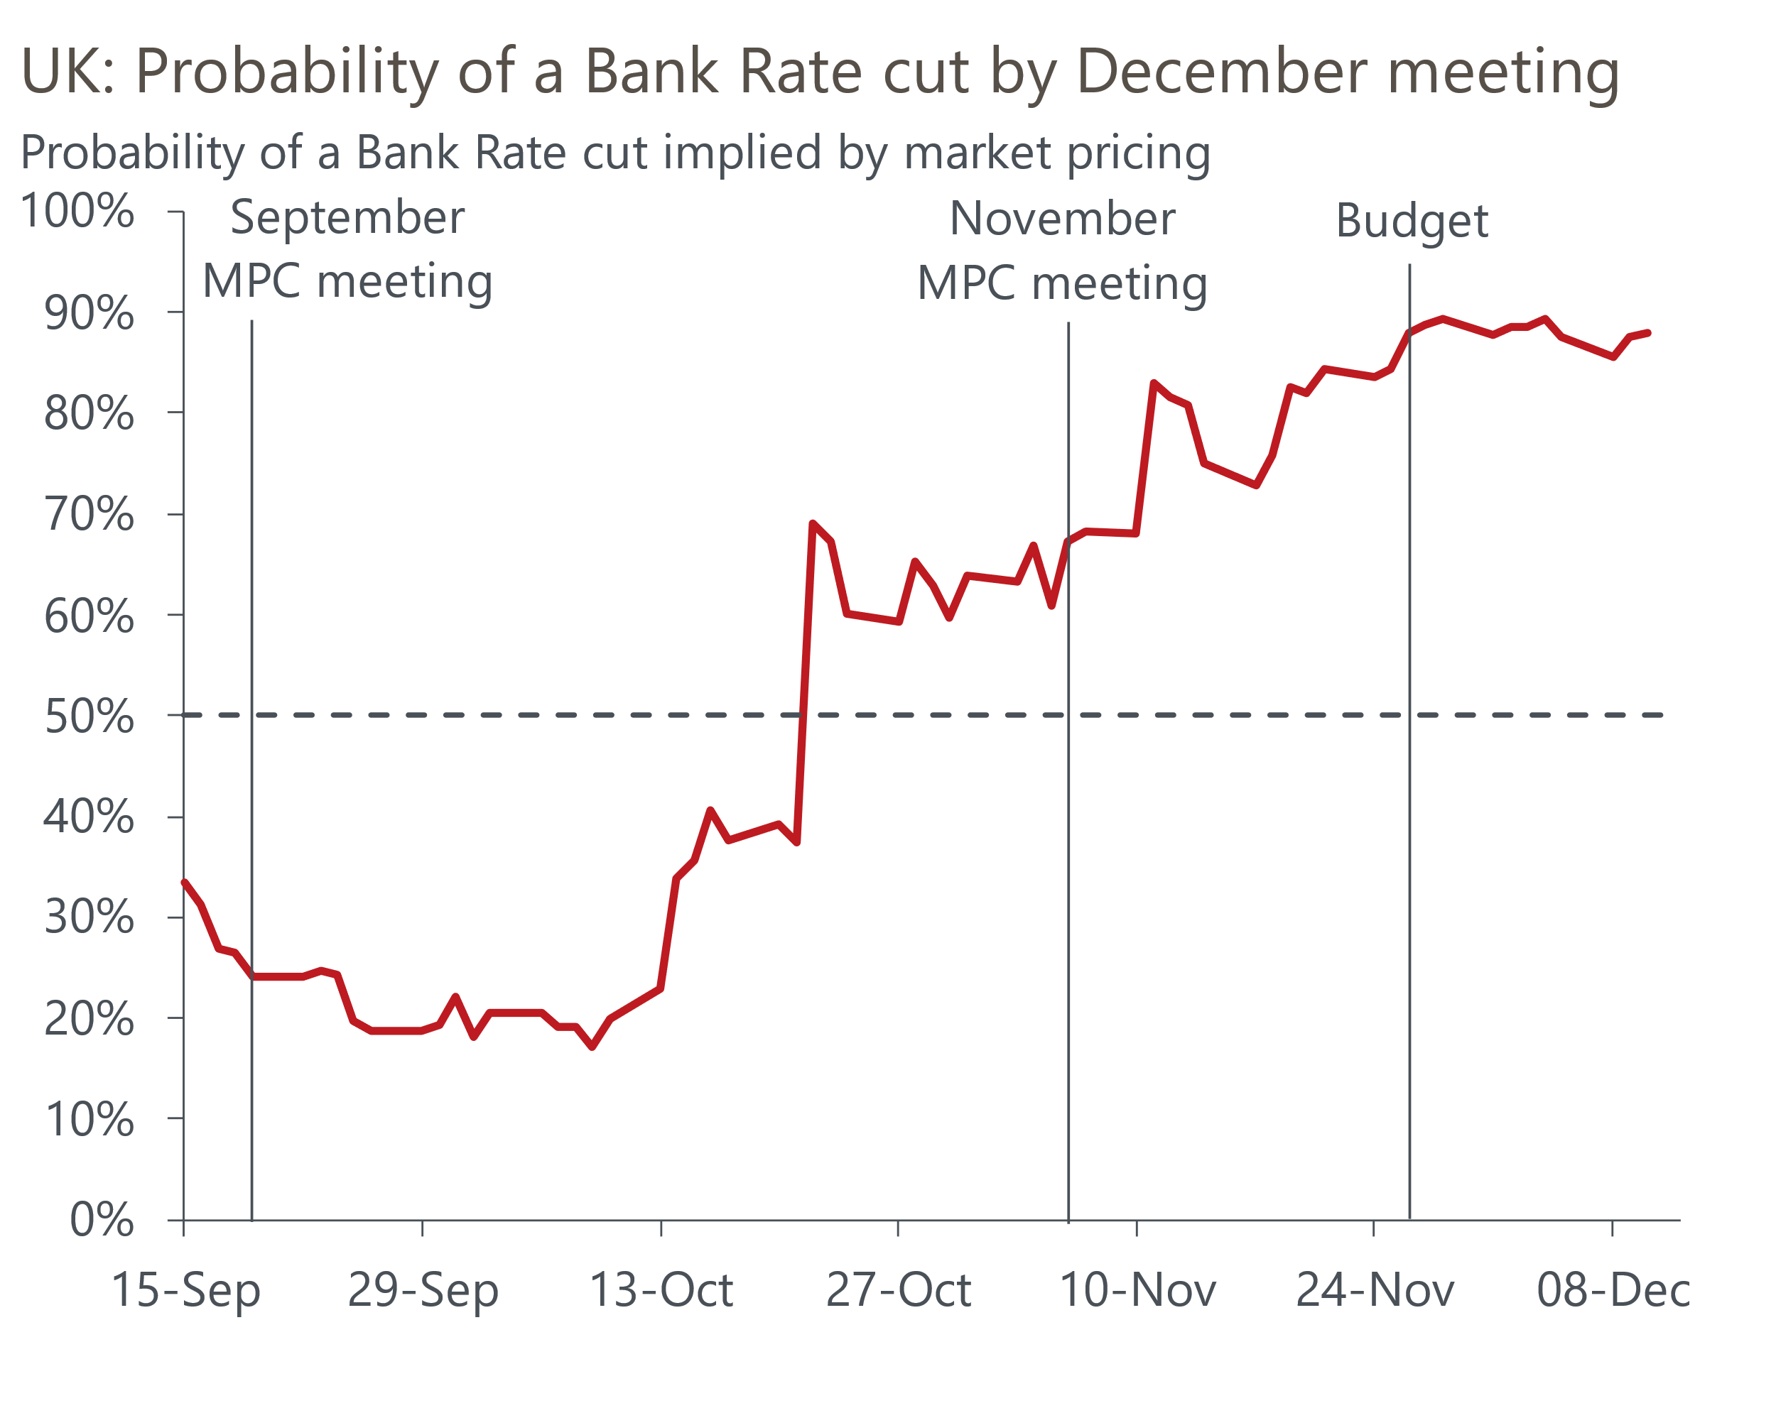
Source: Oxford Economics calculations using data from Haver Analytics
We think the decision is a much closer call than market pricing indicates. But it's notable that Bailey has chosen not to push back against expectations of a December cut. And given his implicit endorsement of a move at one of the next couple of meetings, he will probably prefer to support a December cut rather than go against market pricing and potentially weaken the credibility of future signalling of the outlook for rates.
Developments since the November meeting are unlikely to have altered committee members' views on the outlook for inflation further out. At this week's Treasury Select Committee hearing, Clare Lombardelli stated that BoE staff estimate the Budget will lower inflation by 0.4ppts-0.5ppts for a year from April. But she emphasised that it would be a one-off impact and suggested that members tend to look through such changes. On the activity side, the Budget loosened the fiscal stance a little in the near-term, but the scale of the change was small.
Labour market data have generally been softer, with some evidence of a renewed fall in private sector employment, particularly in lower-paid sectors. So far, this has been reflected in falling earnings growth, with private sector regular pay – the BoE's favoured measure – slipping to a near five-year low on a y/y basis in September.
But there's still significant uncertainty about the direction of pay growth in the new year. The BoE's Decision Maker Panel reported that firms' expectations for pay growth over the coming year nudged up in November, and are at a level higher than would be consistent with the BoE achieving its inflation target over the medium-term.
The minutes of December's meeting should include an update of intelligence from the BoE's regional agents on the likely outcome of 2026 pay settlements. Early indications reported in last month's Monetary Policy Report put 2026 settlements at around 3.5%, down from 3.9% in 2025. This would be a little above the level that most MPC members would be comfortable with. If the agents find that settlements are settling at that level, it will reinforce the likelihood that the committee continues to take a cautious approach to loosening policy.
Therefore, assuming we're correct that the MPC will cut in December, we think it's unlikely they would follow up with another cut in February. So while we expect the minutes will suggest that further loosening is likely next year, the need for caution will be emphasised. Indeed, the individual statements of some of those voting to cut may play down the chances of there being back-to-back cuts.

Table 1: Our analysis of MPC members' views
Member | Last vote | Expected vote | Latest comments
Bailey | Hold | Cut 25bps | "I see further policy easing to come if disinflation becomes more clearly established in the period ahead". "I find the mechanisms underlying upside risks less convincing than those underlying the downside". "Rather than cutting Bank Rate now, I would prefer to wait and see if the durability in disinflation is confirmed in upcoming economic developments this year." "Current market pricing…. is a fair description of my position."
Breeden | Cut 25bps | Cut 25bps | "Data since August have provided me with greater confidence that the disinflation process remains on track and that upside risks to inflation are not materialising." "While the upside risks to inflation have diminished somewhat since the August Report, downside risks from the outlook for demand have become more prominent."
Dhingra | Cut 25bps | Cut 25bps | "Disinflation remains clearly on track, with balanced risks to inflation and downside risks to activity." "My view remains that Bank Rate should have been lower already to account for lags in its transmission to the real economy. Policy is overly restrictive and could exacerbate risks from weak demand and reduced supply."
Ramsden | Cut 25bps | Cut 25bps | "I place weight on our central projection and see risks around it as broadly balanced, although the downside risks are now more prominent for me relative to August." "I judge that our policy stance continues to be restrictive and, based on my outlook, expect that a gradual removal of policy restraint will remain appropriate."
Taylor | Cut 25bps | Cut 25bps | "I disagree with the central projection and my own outlook is weaker. I judge that the current level of slack is larger, and the terminal rate is lower, implying that the current stance is more restrictive than intended."
Greene | Hold | Hold | "I continue to believe inflation risks are to the upside and worry that the disinflationary process has slowed".
Lombardelli | Hold | Hold | "While I expect headline inflation to continue to fall, I worry there may be more underlying inflationary pressure in the economy than embodied in the central projection." "We have plenty of policy space to lower Bank Rate should it be necessary, while a policy reversal would be costly for the MPC’s credibility".
Mann | Hold | Hold | "The inflation persistence scenario is my central case." "Monetary policy needs to rein in both inflation and expectations drift so as to reinforce commitment to our 2% target."
Pill | Hold | Hold | "I continue to prefer a slower pace for the withdrawal of monetary policy restriction than delivered over the past 18 months, reflecting my longstanding concern that structural changes in price and wage-setting behaviour have generated stronger intrinsic inflation persistence in the UK."
Sources: Oxford Economics, Bank of England minutes of the Monetary Policy Committee meeting ending on 5 November 2025

